

SIPNA COLLEGE OF ENGINEERING &TECHNOLOGY, AMRAVATI.
Department of Computer Science and Engineering Academic Year : 2025-2026
Semester: Sixth

A MINI-PROJECT REPORT ON

FARM MANAGEMENT SYSTEM

Submitted for
DATABASE MANAGEMENT SYSTEM LAB

Submitted in
April 2026

Under The Guidance Of

Prof. A. A. Bhuyar

SIPNA COLLEGE OF ENGINEERING & TECHNOLOGY, AMRAVATI

CERTIFICATE

This is to certify that this mini project report entitled

“FARM MANAGEMENT SYSTEM”
has been completed by the following students in the partial fulfillment of mini-project work of the fifth semester, Department of Computer Science and Engineering, During the Academic Session of 2025-2026. This is the record of their work under my guidance and to my immense satisfaction.

Prof A. A. Bhuyar Dr. V.K. Shandilya

Project Guide HOD

(Dept. Computer Science & Engineering)

Group members:
- Monika Sasane.
- Divya Tihile.
- Saniya Umale.
- Simran Wahane.
5.Vaishnavi Punse
SIPNA C.O.E.T., Amravati.

ACKNOWLEDGEMENT

We take this opportunity to express our deep sense of gratitude and hearted thanks to our project guide Dr. Prof. A.A Bhuyar for her invaluable guidance, inspiration and encouragement. It is because of her that we could synchronize our efforts. We also express our sincere thanks to our Head of Department Dr. V.K. Shandilya and Principal Dr. Sanjay M. Kherde for their tremendous support, encouragement and invaluable guidance throughout our project. We shall be failing in our duties until and unless we express our sincere thanks to all the faculty members, both teaching and non-teaching Staff, and our friends who have directly or indirectly contributed of our project work.

Group members:
1. Monika Sasane.
2. Divya Tihile.
3. Saniya Umale.
4. Simran Wahane.
5. Vaishnavi Punse
SIPNA C.O.E.T., Amravati.

INDEX:

Abstract

- Introduction

Software Requirements (Frontend, Backend)

- Database Design (ER- Diagram)

Snapshots

- Conclusion.

Abstract

The main aim of developing “Farm Management System Project” application is to help farmers by providing all kinds agriculture related information in the site. “Farm Management System Project” is web application which helps farmers to share bestpractice farming processes. It helps farmers to improve their productivity and profitability. It enables farmers to sell their products online and farmers can purchase tools and seeds directly from seller. Farmers can view their profile and they can register, edit and delete data.

Introduction

The main objective of this project is to design and develop a user-friendly, efficient, and computerized system that is easy to use and capable of eliminating data redundancy. It aims to create an accurate and flexible system while studying the functioning of a Farm Management System. The software is intended to provide fast processing with a good user interface, ensuring long-term usability without errors or frequent maintenance. It will offer a synchronized and centralized database for farmers and sellers, improving coordination and communication. By computerizing the system, it helps save both time and money, while also providing a better Graphical User Interface (GUI) and reducing the chances of information leakage. The system ensures data security through login and password authentication, supports immediate storage and retrieval of information, and enhances arrangements for farmer coordination, ultimately helping to reduce losses.

Software Requirements

The technology selected for implementing Farm Product Management System is HTML, CSS, Java Script, Bootstrap. The Development was done in Visual Studio Code.

Frontend Technologies :-

  - HTML :- The Hyper Text Markup Language, or HTML is the standard markup language for documents designed to be displayed in a web browser. It can be assisted by technologies such as Cascading Style Sheets (CSS) and scripting languages such as JavaScript. Web browsers receive HTML documents from a web server or from local storage and render the documents into multimedia web pages. HTML describes the structure of a web page semantically and originally included cues for the appearance of the document.

  - CSS :- Cascading Style Sheets (CSS) is a style sheet language used for describing the presentation of a document written in a markup language such as HTML. CSS is a cornerstone technology of the World Wide Web, alongside HTML and JavaScript. CSS is designed to enable the separation of presentation and content, including layout,colors, and fonts. This separation can improve content accessibility; provide more flexibility and control in the specification of presentation characteristics.

  - JavaScript :- is a versatile, high-level programming language primarily used for creating interactive and dynamic web content. It enables developers to manipulate HTML and CSS, facilitating real-time updates and user engagement on websites. As a core technology of the web alongside HTML and CSS, JavaScript is essential for front-end development and can also be used on the server side with environments like Node.js. Its vast ecosystem of libraries and frameworks, such as React and Angular, further enhances its capabilities for building modern web applications.

Backend Technologies :-

- PYTHON FLASK :- Flask is a lightweight, general-purpose web framework written in Python and designed for building web applications. It was created by Armin Ronacher and released in 2010 as part of the Pallets project. Flask follows a micro-framework approach, providing essential tools for routing, templates, and handling requests while keeping the core simple and extensible. Although minimalistic,.

- MYSQL :- MySQL is an open-source relational database management system (RDBMS). Its name is a combination of "My", the name of co-founder Michael Widenius's daughter, and "SQL", the abbreviation for Structured Query Language. A relational database organizes data into one or more data tables in which data types may be related to each other; these relations help structure the data.

Database Design (ER-Diagram)

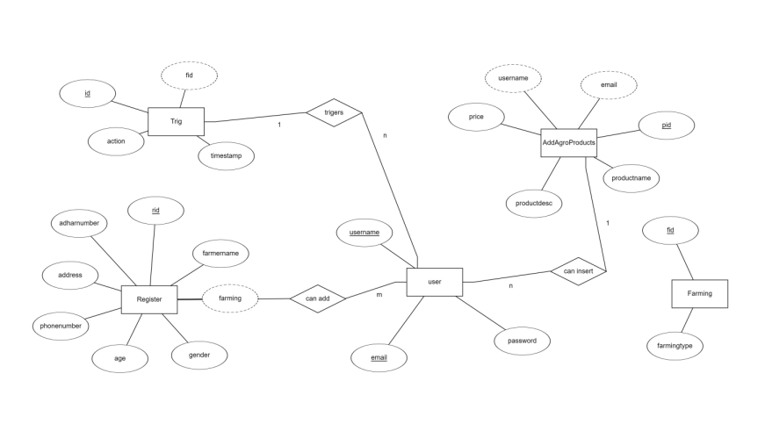

SNAPSHOTS :-

REGISTRATION PAGE (FARMER)

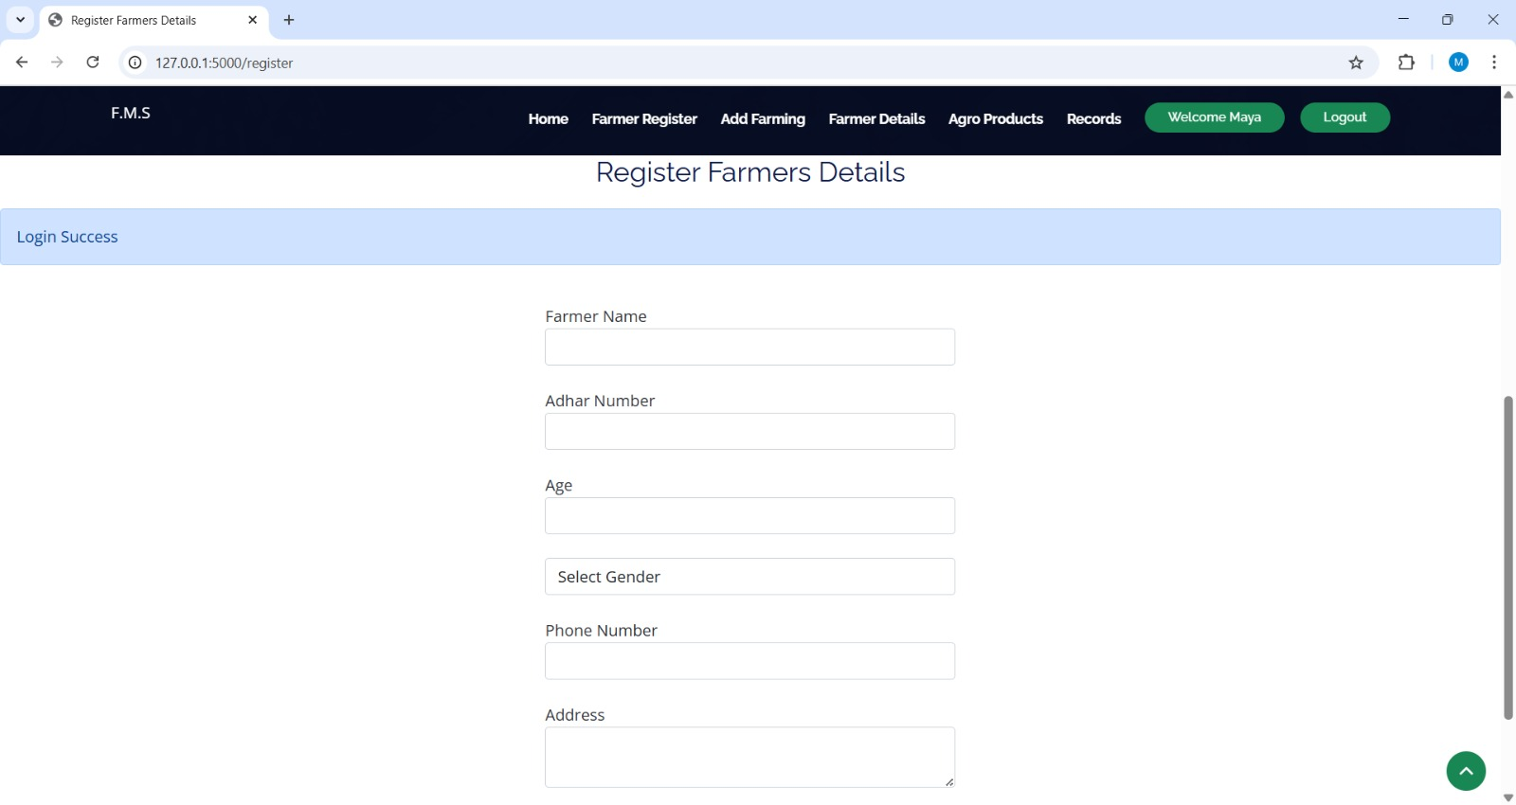

LOGIN PAGE (FARMER)

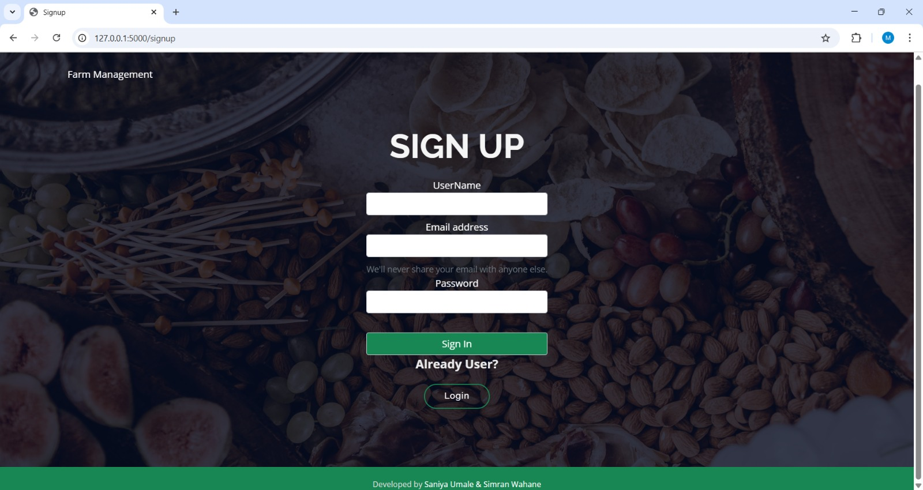

HOME PAGE

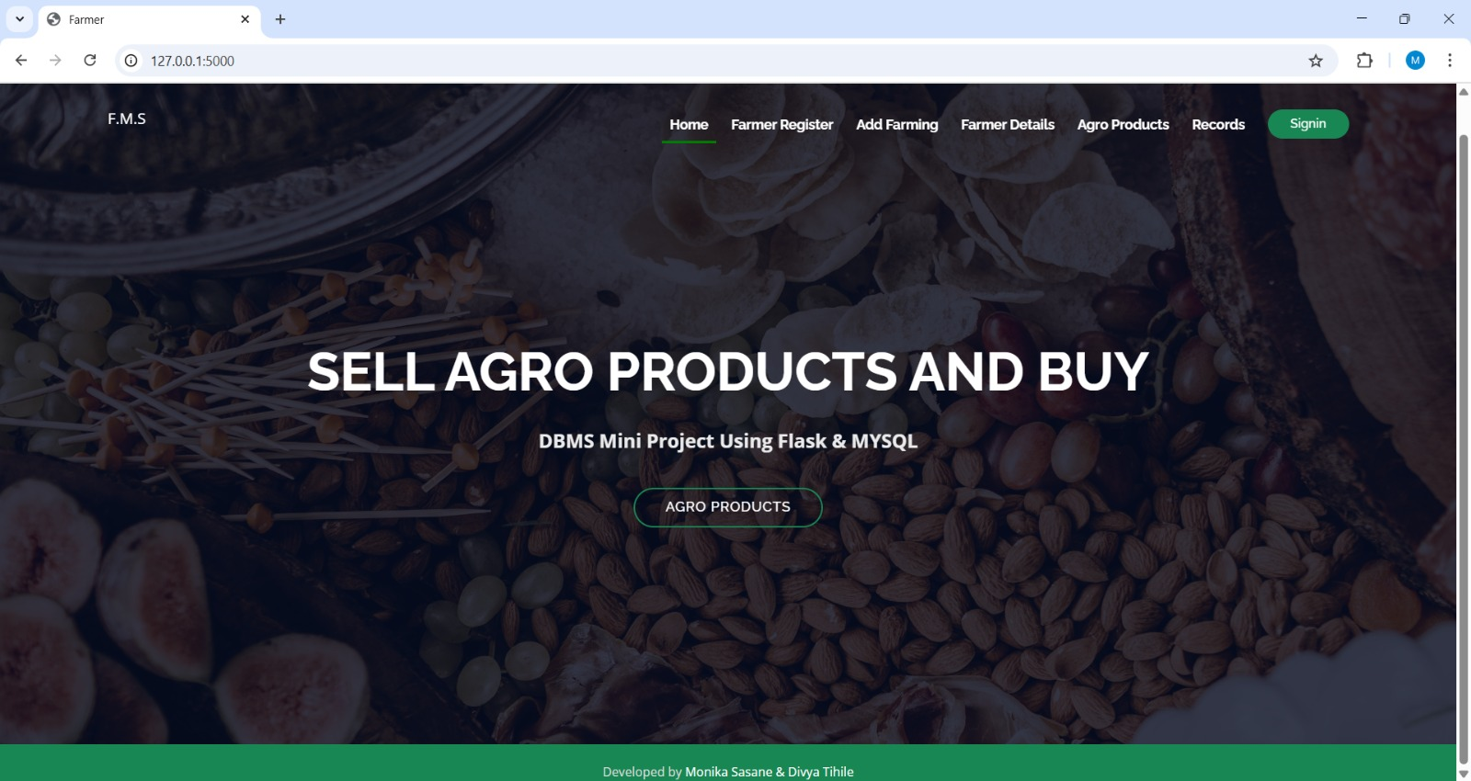

FARMER DASHBOARD

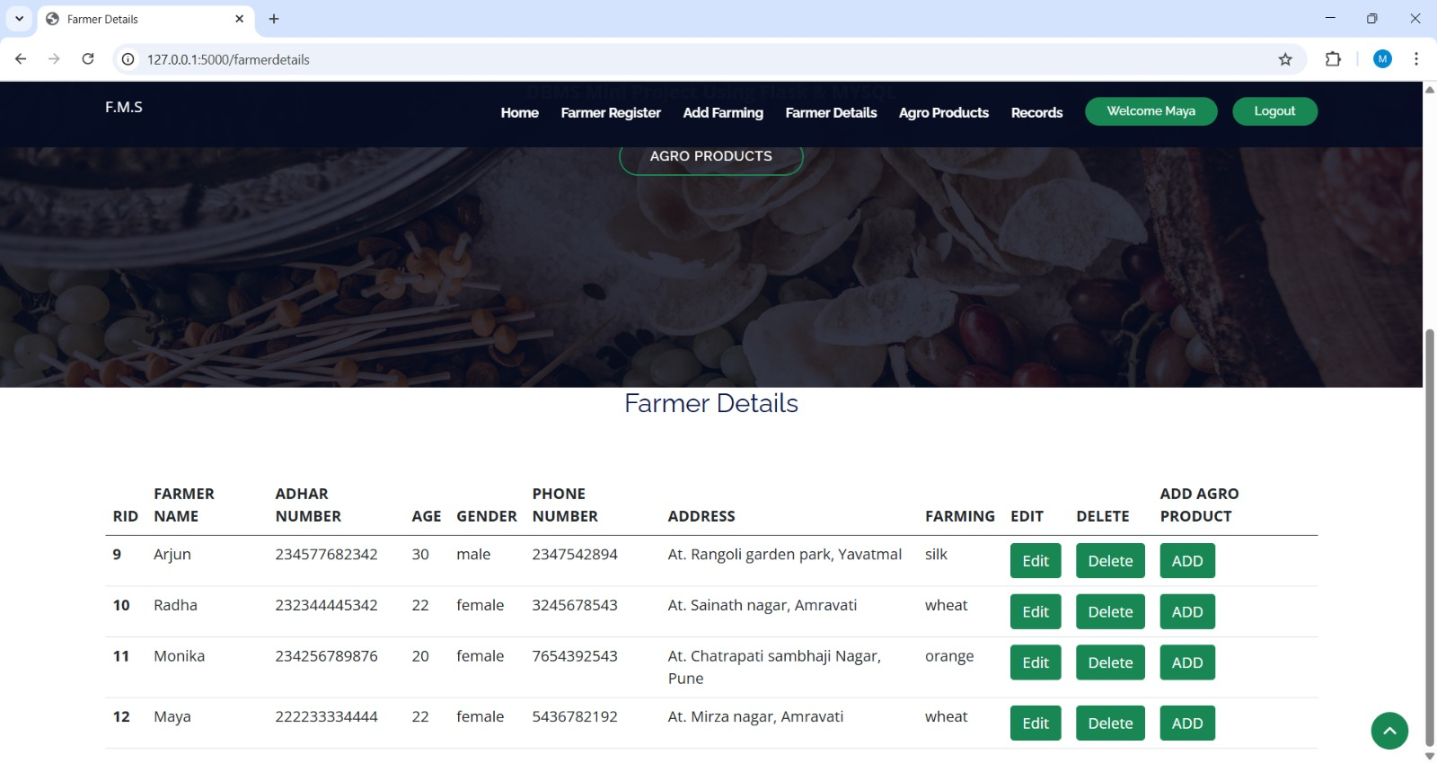

PRODUCT DETAILS

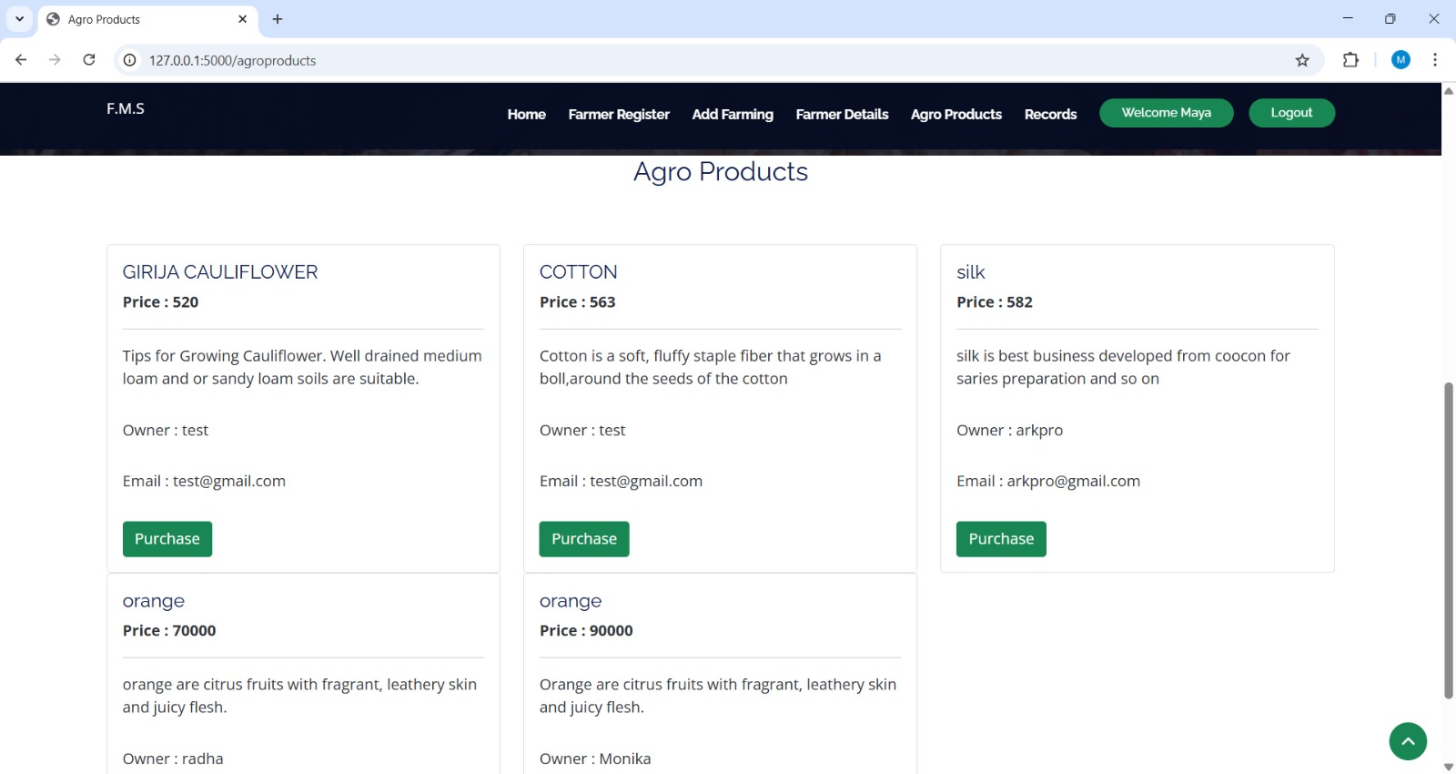

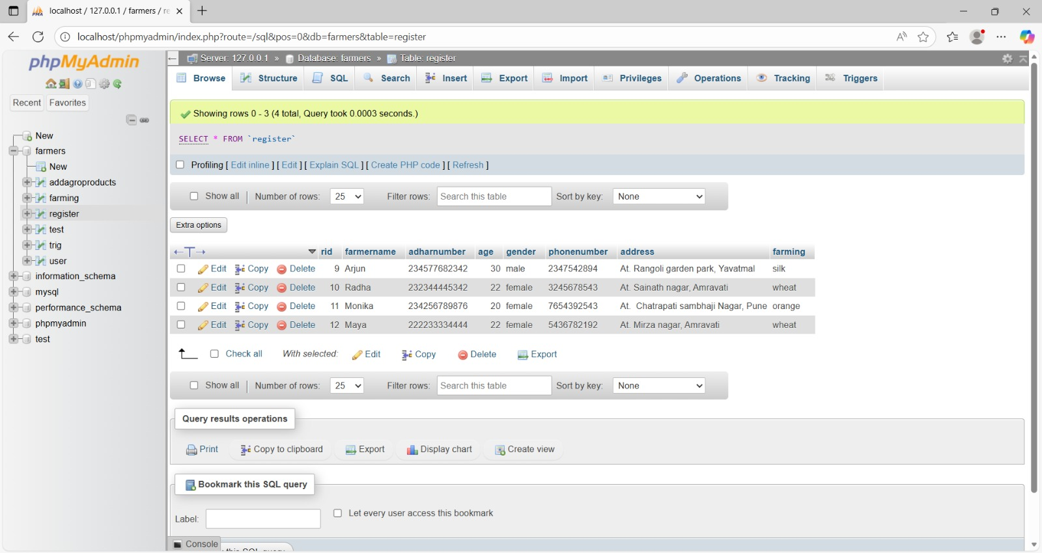

Conclusion

FARM MANAGEMENT SYSTEM successfully implemented based on online selling which helps us in administrating the agroproducts user for managing the tasks performedin farmers. The project successfully used various functionalities of Xampp and python flask and also create the fully functional database management system for online portals. Using MySQL as the database is highly beneficial as it is free to download and manipulated according to the requirements with basic knowledge of SQL. The planning that goes into implementing a project. • The importance of proper planning and an organized methodology. • The key element of team spirit

